<https://gist.github.com/stevencurtis/0f8ab2dc5b439cb78e78947b85480713>

PassBackData:

<https://gist.github.com/stevencurtis/c13caf60ca4a94d385a93355914cc075>

FirstViewControllerPassBackData

<https://gist.github.com/stevencurtis/9705bcdf64da98425eb7f7a042a17dcc>

SecondViewControllerDelegate

<https://gist.github.com/stevencurtis/a05cd2d6f69479238b7e8a9b90258653>

FirstViewControllerunwindToFirst

<https://gist.github.com/stevencurtis/0e4114780ca1336d406d10aaf2741cb7>

MyCustomSegueselfRetainer

<https://gist.github.com/stevencurtis/d0b4ff1e975c2d079e53b13198aa54ab>

Transitioning delegate

<https://gist.github.com/stevencurtis/93195f8d30ecce82bf5ea913b7011b2d>

PresenterUIViewControllerAnimatedTransitioning

<https://gist.github.com/stevencurtis/80bebe369eb0ed832fbac6890137f9c1>

MyCustomSegueUIStoryboardSegue

<https://gist.github.com/stevencurtis/dc4cfa0fc2ea3d1b01eec13ac636f739>

### Segues in Swift

#### Transition between views using the Storyboard?

Photo by [Gregory Hayes](https://unsplash.com/@gregoryallen?utm_source=medium&utm_medium=referral)on [Unsplash](https://unsplash.com/?utm_source=medium&utm_medium=referral)

Difficulty: Beginner | **Easy**| Normal | Challenging

### Prerequisites:

* Be able to produce a “Hello, World!” iOS application (guide [HERE](https://medium.com/swlh/your-first-ios-application-using-xcode-9983cf6efb71))
* Know something about commenting in Swift (guide [HERE](https://medium.com/@stevenpcurtis.sc/commenting-in-swift-344970822725))

### Terminology

Segue: defines a transition between two view controllers in your app’s storyboard file

Storyboard: A way to graphically lay out the UI in Xcode

UINavigationController: A container that stores view controllers in a stack

UIViewController: A view controller is an intermediary between the views it manages and the data of your app

Unwind Segue: A segue used to navigate through previous segue operations

View Controller: Sits between the view and the model, tying them together (usually using the delegate pattern).

### Connecting View Controllers

Using the storyboardto connect a series of UIViewControllerstogether is a matter of dragging and dropping objects on the storyboard.

First the initial view controller is added to Navigation Controller



The following animated GIF shows a how three view controllers can be placed in a row, with a simple segueadded between each one, set as a **show**segue which means that each view controller slides in.



I’ve named the segues **moveToSecond**and **moveToThird**between the first and second view controllers and the second and third view controllers (respectively).

#### Add buttons with actions

We need to add a button for each view controller (in order to write code to kick off the segue).

This is a relatively easy drag and drop operation (only the first button is shown here)



#### Moving Data: Pass Data Through a Segue

It is possible to pass data from one view controller to another using a segue.

Switching to the **first view controller**gives us the following, with the important part that is commented out (FirstViewController is the class related to the first view controller, as shown in the animated gif above), and the button action is expressed.

We are going to use this to segue and pass information from one view controller to another by using performSegue(withIdentifier: String, sender: Any?), tooling it up in the button action.

We update the action to call the segue **moveToSecond**(as named above). Now in this case we don’t need to know the sender, so this can be nil but we need to absolutely be sure that the seguestring is correctly identified. We all know matching Strings is a bad idea, but to avoid it you can see the [lovely written article](https://medium.com/swlh/safe-segues-in-swift-6b38e08bdb9c)I previously made.

But pressing on without String matching, we use prepare(for:sender:)to, well, prepare for the segue. The finished method looks something like the following (which is added to our first view controller):

Now this relies on us having a dataSentproperty in the view controller we are visiting.

So we can place this in the rather attractively named SecondViewController, although it is just a simple property placed within the view controller class.

How best to show these? I’ll go for an animated GIF.



#### Moving Data: Pass Data Back Through a Delegate

What if you want to move data back from the second view controller, we might want to pass data back to the first view controller. One way for this is to use delegation.

To do so, we set up a delegate

We then need to conform to the delegate from the FirstViewController, with which we just print out the message

now within SecondViewControllerwe add in the delegate as a property, which I’ve then chosen to call during the func viewWillDisappear(_ animated: Bool)so whenever the view is replaced the message is sent

There’s a couple of things there, so here is an animated gif



#### Unwind Segue

The **unwind segue**gives us something rather more.

To traverse from First View Controllerto Second View Controllerto Third View Controlleris a stepwise process. However, an unwind segue gives the ability to move from Third View Controllerto First View Controller, skipping the Second View Controllerentirely.

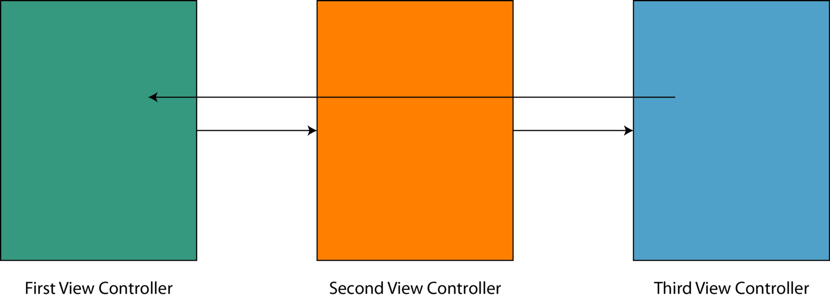

Step in the unwind segue!

In the FirstViewControllerthere needs to be a func unwindToFirst(_ unwindSegue: UIStoryboardSegue)function that will run when the storyboard moves back to the FirstViewController.

The storyboard section of this by control — dragging from a button to the top-right hand button “exit”

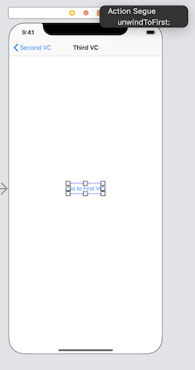

So difficult to show! Here is the animated GIF



It is also possible to pass data through the segue in a similar fashion to that described above.

### Create your own, custom Segue

One reason to create your own segueis to create a nice animation when a view is presented.

My animation? A Fade Out (representing our fading from life, love).

The segue we create is a Custom **Segue**(rather than the show segue above).

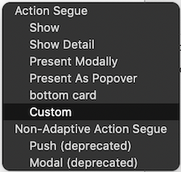

Within this **Segue**we Need to select the Class of the segue, and set an identifier. Here we call it customSegue.

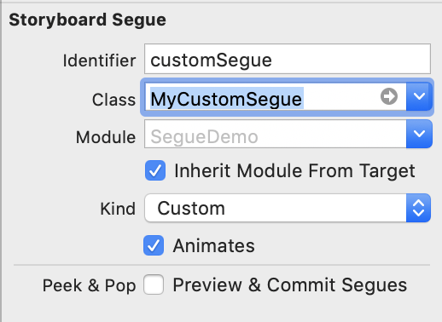

This then uses a whole new file to cover the newMyCustomSegueclass; I’ve rather creatively called this file MyCustomSegue.swift , that inherits from UIStoryboardSegue.

The segue’s action will be, well, performed in the perform function with is overridden. override func perform()d

Let us take perform()step-by-step. To gain control over the transition we set MyCustomSegueto be the transitioningDelegate. At the top of the class there is a retained reference private var selfRetainer: MyCustomerSegue? = nilthat is required as UIKitdoes not retain instances of UIStoryboardSegueso a strong reference is created to the same. The presentation style is set to .fullScreento replace the original view controller.

The transitioningDelegateprovides methods that work for the presentation and dismissal. We will introduce two classes, Presenterand Dismisserto deal with those, that they adopt UIViewControllerAnimatedTransitioningand NSObject.

The presenter is quite easy to write.

Here we have the Presenter meets the protocol having the functions func transitionDuration(using transitionContext: UIViewControllerContextTransitioning?) -> TimeIntervaland func animateTransition(using transitionContext: UIViewControllerContextTransitioning).

The former of these is simply a time, 1.5 is a rather nice span of time for this fade animation.

The letter is the animation; so the fade will be for the presenting view controller from translucent to opaque (that is 0.0 to 1.0).

What is that? You want a Playground with everything included? I’ll give you that, then:

Better will be a whole Repo with the work on it. Ok, that’s at the bottom of this page.

### Conclusion

Segues are not as easy as one might think, but they allow you animate the user’s journey through your App and push data around.

Who would not want that?

I hope this guide has given you a nudge in the right direction for this (albeit fun) way of transferring your user and their data around an App.

### The repo link

[**stevencurtis/SegueMediumPost**  
SegueMediumPost. Contribute to stevencurtis/SegueMediumPost development by creating an account on GitHub.github.com](https://github.com/stevencurtis/SegueMediumPost.git)

### Extend your knowledge

* Apple have created documentation for segues [HERE](https://developer.apple.com/library/archive/featuredarticles/ViewControllerPGforiPhoneOS/UsingSegues.html)

### The Twitter contact:

Any questions? You can get in touch with me [HERE](https://twitter.com/stevenpcurtis)